



**Senior Design Project:**

PeerConnect (Student version)

**Jody Whitis**

**Abstract**

Students who are new to the university often get lost and don’t know where they are going. A problem that faces new students is getting familiar with the university and learning how to organize themselves without any distractions. A project can be developed that can help new students learn their new campus and be able to become efficient with their studies. The project will be an application design to help users organize and arrange meetings for student or employees based on maps, appointments, and messages. The application can be used by universities and companies where user can arrange meetings with others and remainders can be sent as a message to the app. This app can be beneficial to companies, but it will be used with the university. The application will feature places of importance in a university as pins on a map. The meeting will feature a place that will be located based on map coordinates. A list of the user’s names who are to attend the meeting will be saved for check ins. Using this app, users can check in and will display how many people are currently on the meeting. Messaging will also be a feature for appointment remainders and communication to different users. Users can make a list of activities to do for each meeting.

**Contents**

1. **Introduction**…………………………………………………………………………………………………………………….…..….2
2. **System Requirements/Protocol Overview**……………………………………………..………………………...……..3
   * 1. Software Requirements……………………………………………………………………………………………….….4
3. **Approach and Implementation**………………………………………………………………………………………………4
   * 1. Software Implementation………………………………………………………………………………………….…..5
4. **Testing & Results**…………………………………………………………………………………………………………………..12
   * 1. Operation Procedure…………………….……………………………………………………………………………….13
     2. Prototype Testing…………………………………………………………………………………………………………..13
     3. Final Results……………………………………………………………………………………………………………………14
     4. Future Work…………………………………………………………………………………………………………………...14
5. **Conclusions**……………………………………………………………………………………………………………………….…..14
6. **Introduction**

New students and employees have trouble finding places within their school or company. Many of them also don’t know who to meet and where to go. According to new students, many of them are late because there are not familiar with the university. Employee can also be late to their meetings because they are still learning their place of work. Many people need to be able to organize and become more productivity. In a world where many people use technology as a means of entertainment, it may also become a distraction. One way to solve this problem is to have an app that can help productivity without the need to open other apps.

The idea of this project is to be useful for new people entering their areas. Employees or students who are already there will also need to organize and meet based on conveniences and locations. This application can be useful to help organize meetings and list them with an area of interest. These places are known by the current students and will help newcomers become familiar.

**1.1.1 Objective Statement**

This app will use a login system to authenticate users that are affiliated with the university. The user’s information will be saved into an SQL database. The current user’s information will be saved temporally until the user exits the application. The messaging feature will use UDP sockets to communicate with other people. A list of names will be displayed without the need to know or enter their IP address. The application can communicate with another person who is currently logged in. Google Maps will be used to display the university. Custom pins will be added to highlight buildings and places of interest. It will help make the map more detailed in case some buildings don’t show on the map. A section to create a list of current courses will be used for the university version of the app. It will display the user’s current courses and help manage meetings for each class. The user interface will be design as simple as possible for the user’s convenience. The user will navigate the app through a simple button menu. This will make it easier for the students to use the app and will not require a detailed instruction manual.

1. **System Requirements / Protocol Overview**

**Protocol Overview:**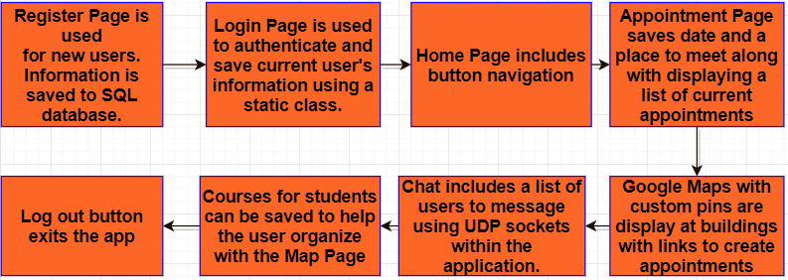

The specifications needed for this project as well as features that will be implemented:

User Login System:

* User will register with username, password, name, id number on an SQL Database.
* User can also add their courses on a separate table with id number as foreign key.
* User’s state is saved for the current user until the application exits.
* User will navigate the app using buttons linking them to each page.

Appointments:

* Appointments will be saved on an Appointments Table with information and the user’s id number.
* The Appointments Table will be linked using the student id number as a foreign key.
* A student can make as many appointments as needed.
* Locations with custom pins will be saved in the table.

Messaging:

* UDP sockets are used to connect to another user’s IP and port numbers.
* Port numbers will be save in the current logged in user’s information.
* The messaging page will use names to connect without the need to know IP or port numbers from the user’s side.

Maps:

* Custom pins with places relative to the application’s version (school or company) will be displayed.
* Buildings and place will be saved with X and Y coordinates in the Places table and the Maps class.
* Hover over pins displays the location name, clicking on the pin links the user to the appointment page

**2.1.2 Software Requirements**

The software requirements, this project will use C# as the programming language for the windows version along Xamarin for the mobile version. Xamarin is a platform for mobile development used with IOS and Android. This will help the logic codes in C# be more compatible with the whole project. It will also make porting to IOS and android easier as a future aspect of the project. Google Maps will be used for the projects location features.

**3. Approach and Implementation**

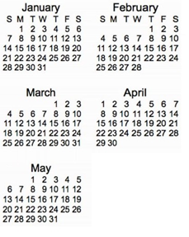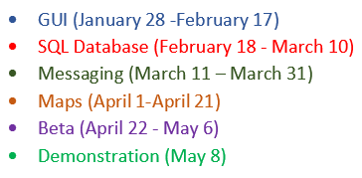

**3.1.1 Software Implementation**

In this section, the project will be described along with problems and goals following the software development cycle. The steps taken for the project will also be described noting which features were developed and deadlines for each aspect of the app.

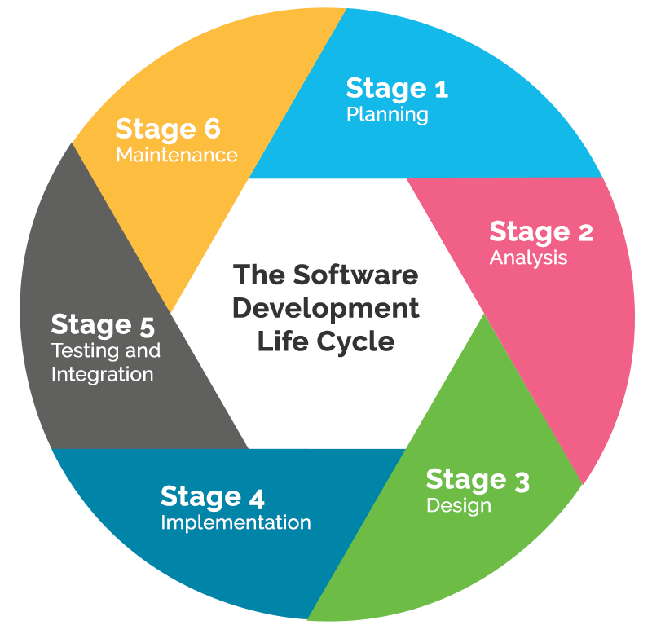

**1. Planning:**

During this phase, the timeline for the project was decided based on features. The list of features that will be include along with the number of weeks to add and test individual features as also decided.

**2. Requirement Analysis:**

The projects goals and expected outputs of the application will be specified in order to design the program.

**3. Design:**

The Design phase involved specifying the modules and components of the system and how they connect with each other. A list of features and designs for the project were brainstormed and decided.

**4. Implementation:**

Once a list of features and designs were chosen, implementing them was the next step. This involved researching and learning new features that were not previous used before. Testing each feature along with implementing and documenting required more time than other phases of the project.

**5. Testing:**

In order to test our code, a custom-made user is registered to test the GUI and features on in Visual Studios.

**6. Maintenance:**

Once the application successfully ran for the first time, there were still improvements to make to the core features. Maintenance will be needed along with porting to mobile which will require the project to build on a Mac computer and use a working android device.

**Source Code:**

**StudentTable:**

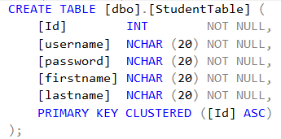

**NetworkTable:**

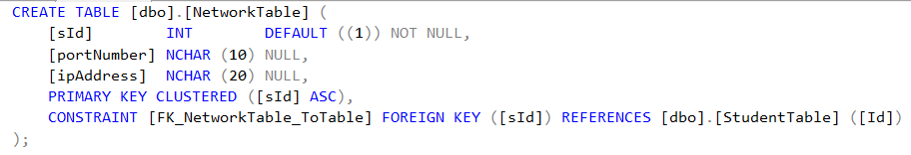

**LocationTable:**

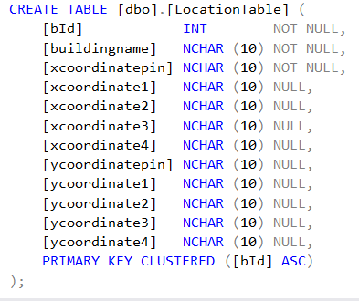

**CourseTable:**

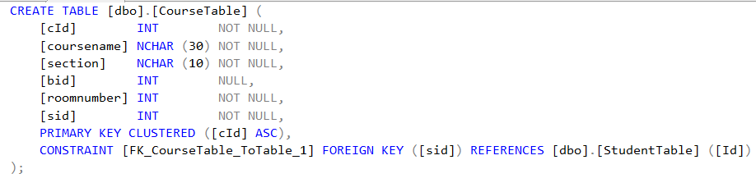

**AppointmentTable:**

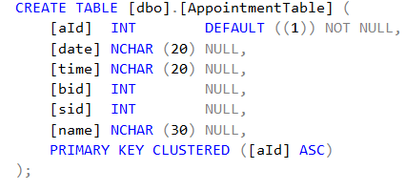

**LoginPage.cs**

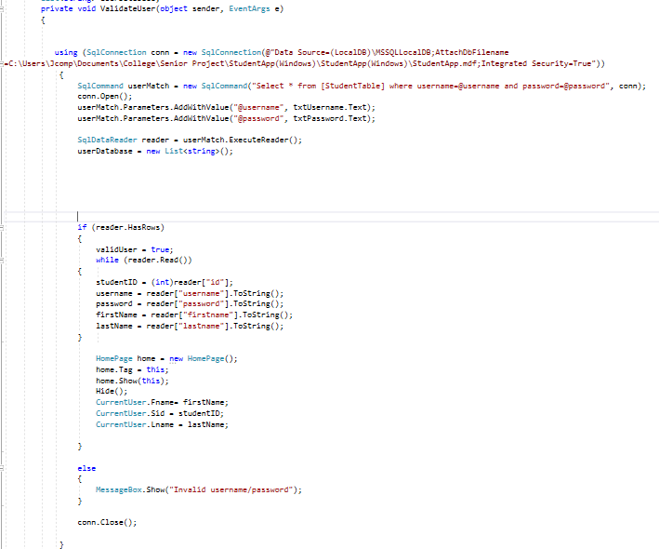

**CurrentUser.cs**

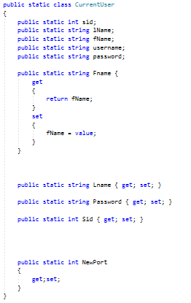

**Appointment.cs**

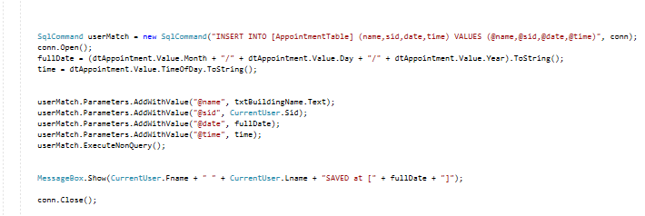

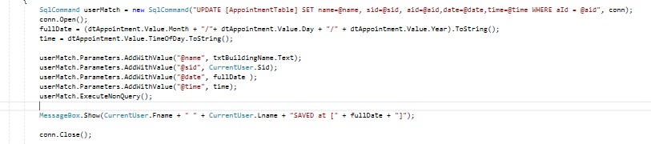

**Chat.cs**

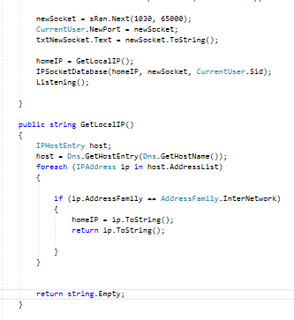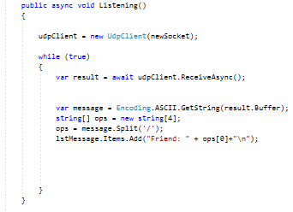

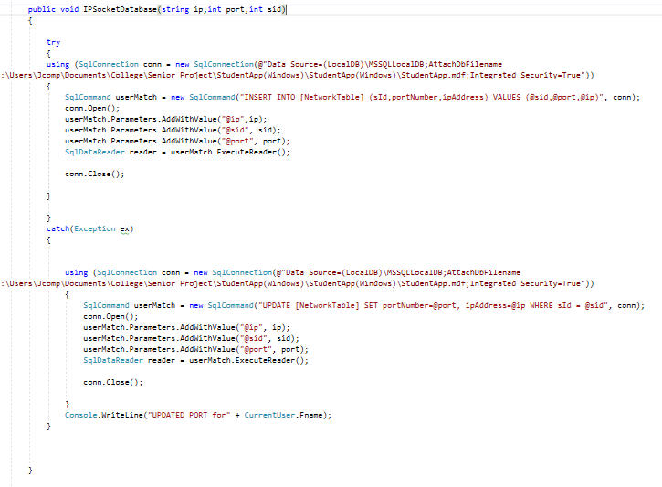

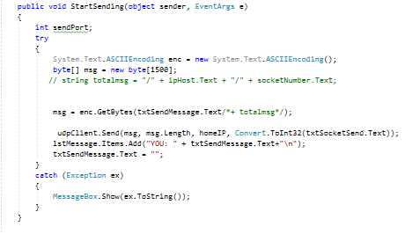

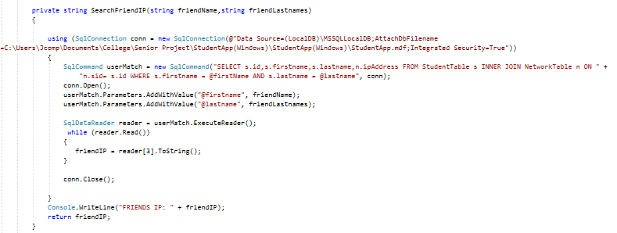

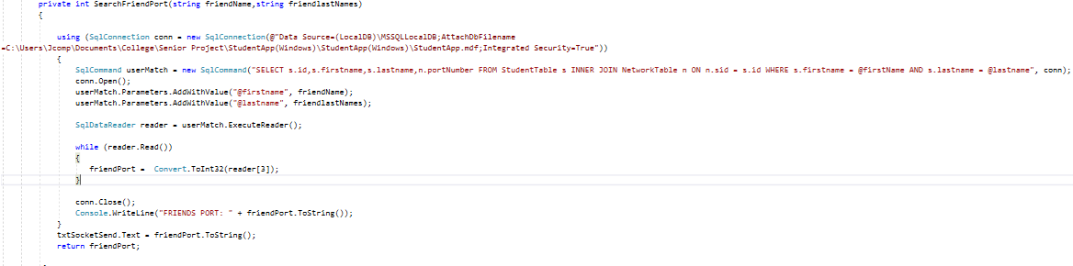

**Maps.cs**

Building coordinates Building polygons coordinates

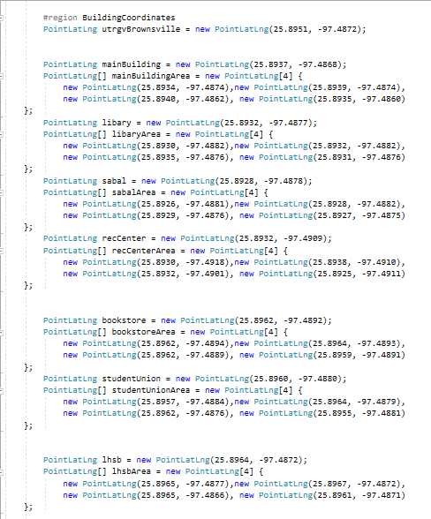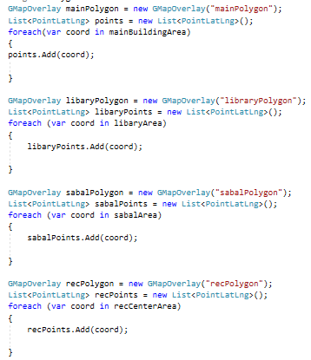

Polygon fills Pins for buildings

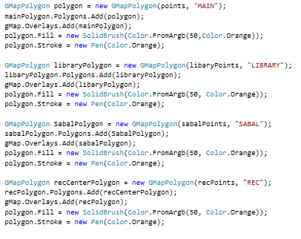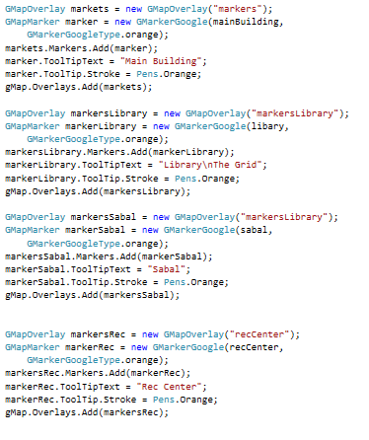

**4. Testing & Results**

After implementing the software, testing was performed on the system to check the core features. The user interface and transitions to each page were tested until the pages displayed properly. Database queries were also tested and debugged until they gave correct results for the login and password. Maps were modified to include the names of the buildings. The socket class was corrected to communicate and be used with a list of names instead of inputting IP and socket numbers manually. This function worked properly and was tested on different networks.

# 4.1.1 Operation Procedure

* 1. Open the app and log in or register.
  2. If the user is registered, then the user logs in with username and password.
  3. The user’s information is selected from the SQL database and returns their information to proceed to the homepage.
  4. If no results are returned, then a message will tell the user their information is incorrect.
  5. If the user is not registered, then go to register page.
  6. The register page will save the username, password, name, and id number and will return to the login page.
  7. Homepage will use buttons to navigate to different pages.
  8. Courses Page will save the courses and list the current registered classes.
  9. Maps Page display the campus with pin at different buildings.
  10. The pins will display the name of the location of interest.
  11. Clicking the pins will take the user to the appointment page to set up a new appointment.
  12. Chat Page will display a list of registered users to communicate with using UDP sockets.
  13. Clicking on the name will automatically return their IP address and port numbers without displaying them.
  14. Messages can be sent without the need to type or know the IP or socket numbers.
  15. The log out button will end the user’s login session and exit the application.

**4.1.2 Prototype Testing**

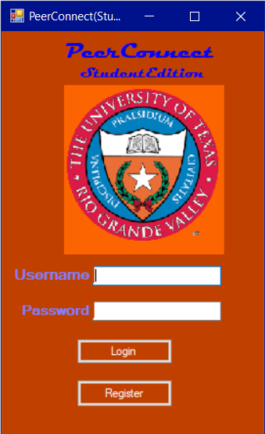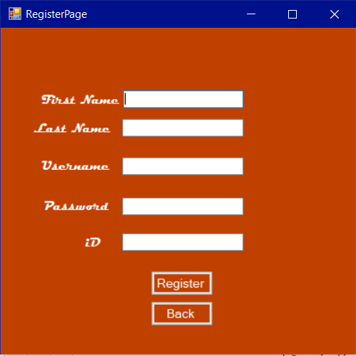

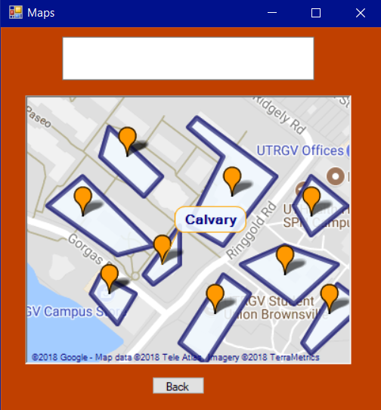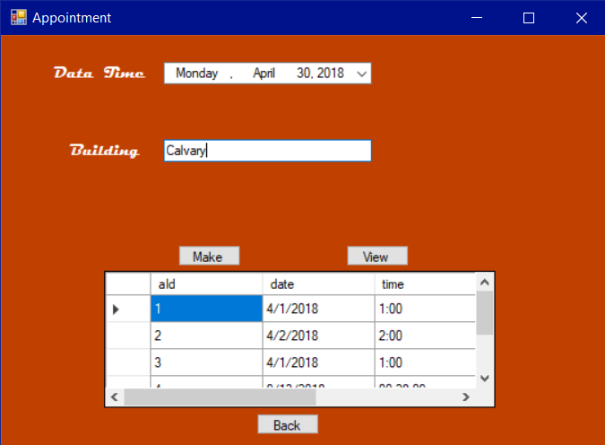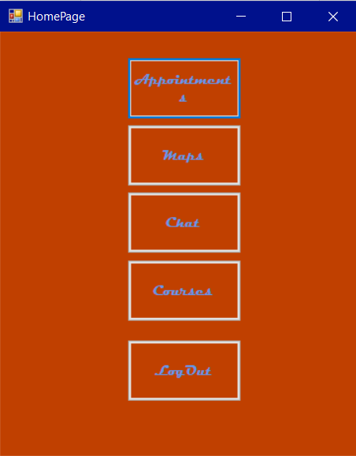

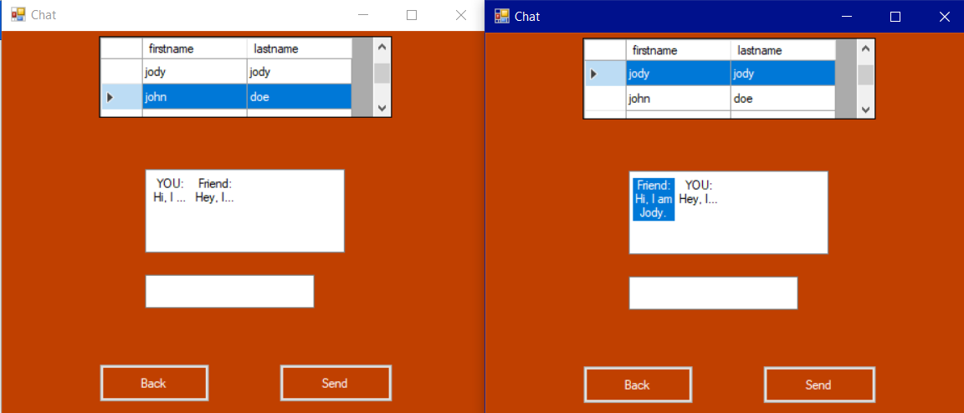

**4.1.3 Final Results**

After several tests involving database query, sockets, maps and event driven buttons, the core components of the project were successfully completed. The results are listed here:

* The app can register users and authenticate correctly.
* Appointments are saved and displayed on the page.
* The chat feature displays names and can send messages to the correct user.
* Maps display with the right zoom level and highlighted areas for custom pins.
* The database queries insert the right information and returns the desired results.
* Most of the core features work as designed. More features and coding improvement will be needed in the future.

**4.1.4 Future Work**

Future modifications/Additions to this project in the future could include:

* Improved GUI theme with improved coding for page transitions.
* Porting to IOS/Android devices using existing logic codes.
* Improved Databases with more organized tables.
* More appointment features.
* Enhanced features for maps.
* Hashing for user id’s and IP addresses.
* Customizing features for users to select their own themes and colors.
* More Location pins added to the maps page.

**5. Conclusions**

The project for most of the features were successfully finished. The most difficult part of this project was getting used to the android feature for the user interface and making them work properly with the base C# coding. Android and cross platforming have plenty of features to learn from and implementing them took some time. A setback for the project was the emulator not working properly. An emulator on visual studio was used to test the project, but this emulator made the system performance slow. Due to the emulator not function the windows version was used to demonstrate the project. Porting had the cost of a mac computer to build it for IOS. For convenience and making it cost effective, the windows version was developed first. The android and IOS versions will be the next goals for the project. Maps API, a new feature is included and the preparation to implement it took longer time than anticipated. Overall the main project was successfully completed and porting to mobile and adding more features will be planned in the future. This app can be a useful tool to encourage students and employees to become more productive.